Geometry: Unit 12, Lesson 6

- An equation is shown ${\left(a\right)\left(a +9\right)=10}^{2}$. What are the solutions to the equation?

$$1 and-10$$
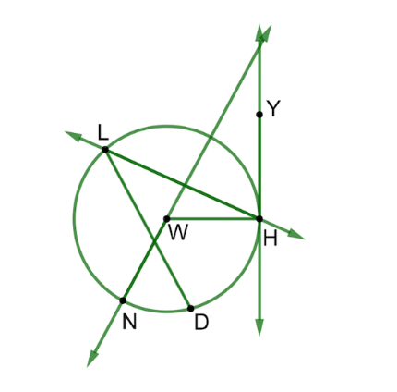

- Circle $W$ is shown with points $L,H,D,$ and $N$ on the circle and point $Y$ outside the circle. Complete the table by identifying the type of line or segment.

Line or Segment | Type
$$\overset{⃡}{YH}$$ | $$Tangent$$
$$\overline{WH}$$ | $$Radius$$
$$\overline{LD}$$ | $$Chord$$
$$\overset{⃡}{LH}$$ | $$Secant$$
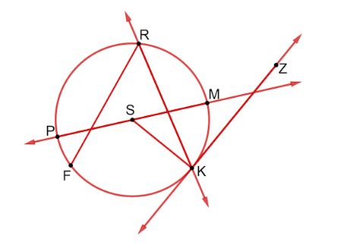
- Circle $S$ is shown with points $R,M,K,F,$ and $P$ on the circle and point $Z$ outside the circle. Complete the table by identifying the type of line segment.

Line or Segment | Type
$$\overset{⃡}{RK}$$ | $$Secant$$
$$\overset{⃡}{KZ}$$ | $$Tangent$$
$$\overline{PM}$$ | $$Chord$$
$$\overline{RK}$$ | $$Chord$$

